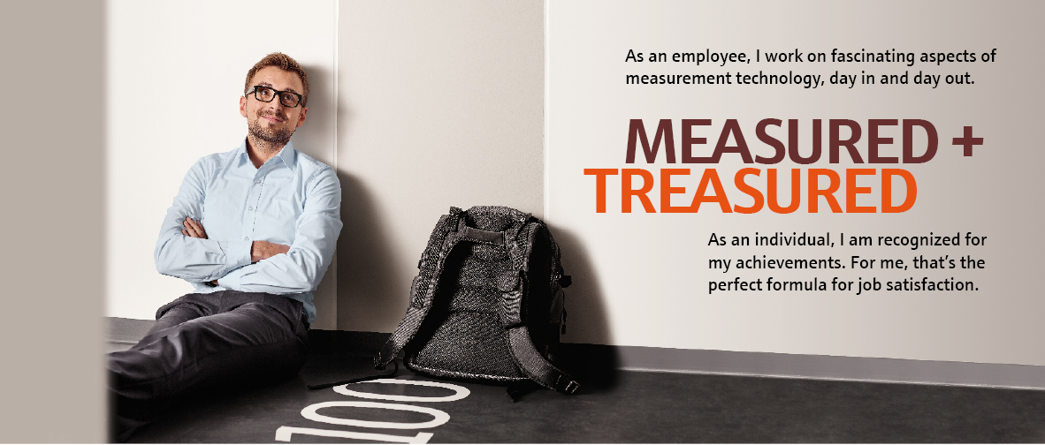
Discover your own perfect formula for job satisfaction
Our sales center in Korea is currently looking for a
Field Service Engineer
Endress+Hauser is a global leader in a measurement instrumentation, services and solutions for industrial process engineering. Despite employing almost 13,000 people worldwide, we have remained a family company, and are proud of our close-knit working environment. There are always two sides to working with us – the professional and the personal. Together they add up to a more rewarding career, day in and day out.

Roles & Responsibilities
Responsibilities and Roles (R&R) include but not limited to:
- Travelling to customer site to assist with commissioning, maintenance, repair, diagnosis and upgrade/update of instrumentation.
- Minimizing customer downtime and increasing customer satisfaction of Endress+Hauser instrumentation and services in an efficient, safe, quality and cost-effective manner.
- Providing trainings to customer maintenance staff on maintenance repair, commissioning of Endress+Hauser instrumentation.
- Providing feedback to sales team to report potential opportunity to sell Endress+Hauser products and solutions.
- Identifying root cause problem and providing resolution on site using personal as well as technical expertise.
- Arranging and following-up demos and trials at customer site.
- Handling of repairs and returns.
- Managing spare part upon requests.
- Developing and maintaining service database.
- Understanding and taking ownership of intrinsic aspects of after sales in terms of responsiveness, quality, time-efficiency and customer-friendliness.

Qualification
Education
- Bachelor’s degree in electrical/mechanical engineering or related field.
- Experience in calibration service and commissioning of instrumentation is a plus.
Languages
- Fluent in spoken and written English.
- TOEIC 850 above preferred.
Personal requirements
- Technical knowledge of Endress+Hauser's products and process applications.
- Analytical and problem solving skills to address customer needs.
- Ability to deal effectively with customer complaints, technical inquiries, and provide general telephonic assistance.
- Skillful in practical hands-on service activities with experience in commissioning and calibration of industrial plants.
- Committed, responsible and initiative working attitude.
- Ready to travel domestic and international.
- Proficiency in MS Word, MS Excel.
Contact us
- 채용 담당 : 인사담당자 (02-3660-0367 / hr@rok.endress.com)
Apply
전형방법 :
- 1차 서류전형
- 2차 영어 필기 테스트 & 기술 테스트
- 3차 인사부 & 부서장 면접
- 4차 임원진 면접
제출서류 :
- 자사 양식의 국문이력서 제출
- 자사 양식의 국문이력서는 하기 홈페이지 오른쪽 다운로드란에 '입사지원서 (신입사원)'을 다운로드
https://www.kr.endress.com/ko/career/your-employer/Endress-Hauser-Korea-Career
- 추후 합격시 이력서와 관련된 증빙자료 제출
접수방법 :
- 이메일: hr@rok.endress.com

